Technologies:

* Netbean IDE v12.3
* Xampp v3.2.4 for MySQL

**\*Import database**

Step 1: After Install Xampp and MySQL like this:

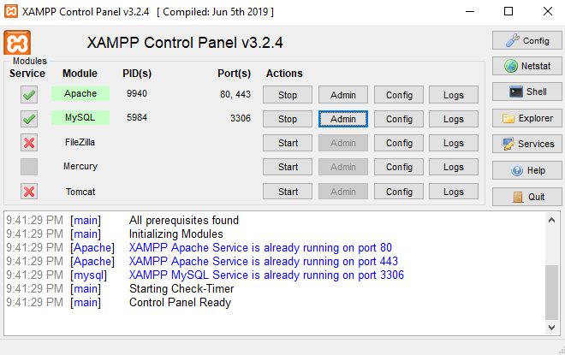

Step 2: Click on Admin of MySQL button, we will see the database page:

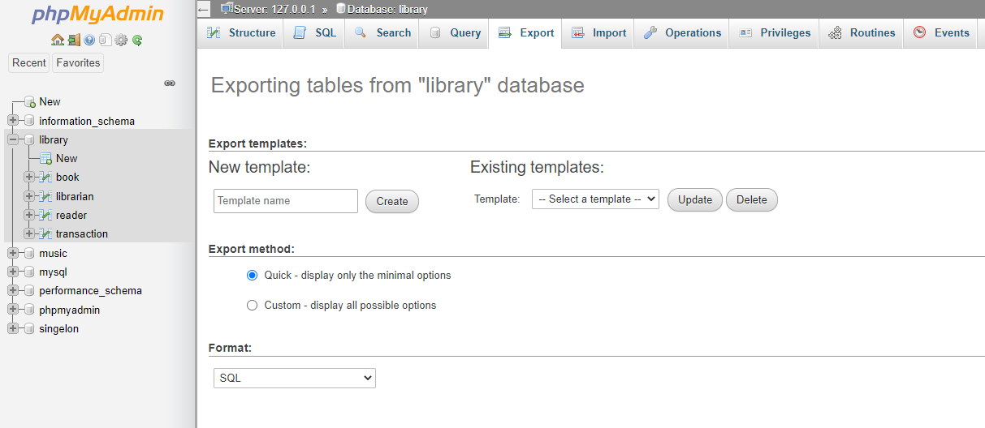

Step 3: Create new database with the name is “library”

Step 4: Choose tab import and select the “library.sql” file to import database

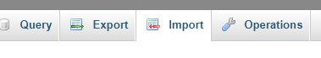

**\*Run Project**

Step 1: Open Netbean -> Create your new Project -> move “Parttern” folder to your “src” folder of the project

Step 2: Add MySQL JDBC to library, Right click on libraries folder -> choose add JAR/Folder

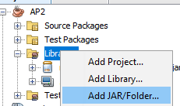

Step 3: Move “JDBC for MySQL” folder, add this jdbc like below

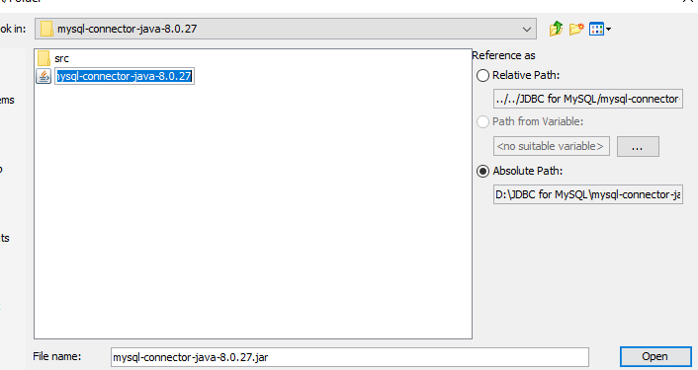

Step 4: Right click on Project and Choose “Clean and Build”

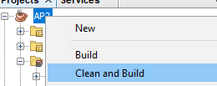

Step 3: Open packet “Pattern.library.jframe” and run file “loginJF.java”

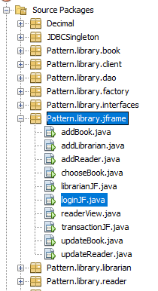 & 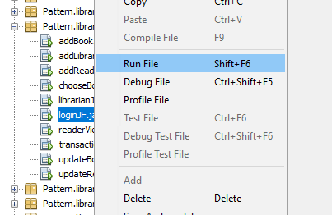

Step 3: Login with admin account

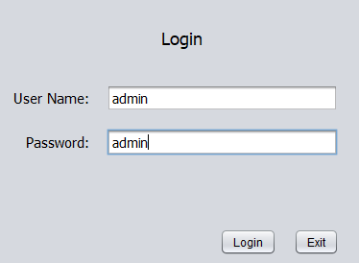

Also you can manage database connection here: “Pattern.library.dao -> connectiondb.java”

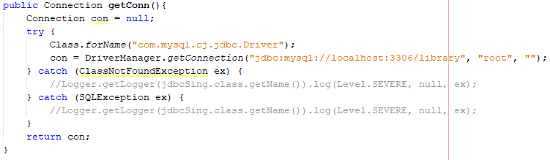

MySQL Port is 3306: 

“localhost:3306/library” library here is the database name

“root” is the username to connecting the database and beside that is password with empty. This account is default of MySQL